Chapter 9 Review chapter 8/9 before completing the following activity:

**Interpersonal Activity:** Facetime someone in class (OR email me and I would be happy to work with you☺) and work through the following questions. One of you take the odds and one of you take the evens. When you are finished SWITCH roles and do it again (so that each of you has had practice listening and responding to all of the questions, then document your results below here! Work together and figure out good upper level responses for each of these, then f**ill in the grid below with the documentation of this task: Make sure to put the work in on these, because we will be finishing up our book with a flipgrid which will include these questions and answers.**

|  |  |
| --- | --- |
| With whom did you speak? |  |
| Date you had the conversation? |  |
| How long did the task take? |  |
| Document in English ONE interesting answer your partner gave? |  |
| How well do you think you did? |  |

**Questions Responses**

Chapter 8 discussion questions

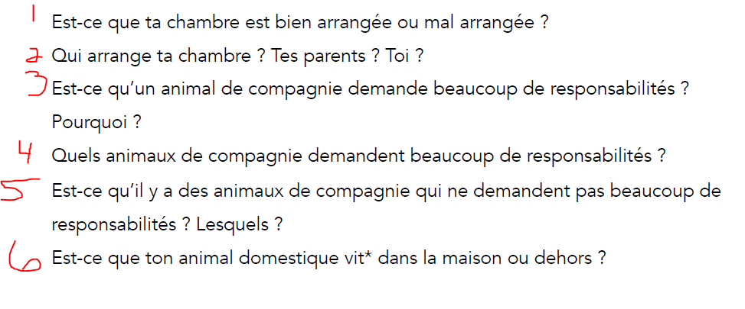

Chapter 9 discussion questions

